|  |  |  |  |  |
| --- | --- | --- | --- | --- |
| **WEEK** | **VALUE PROMISE** | **MEMORY VERSE** | **CHARACTER TRAITS** | **WORK HABIT** |
| **TWO** | “ I believe in only one God as my God ”. | Matthew 25:35 | 1. Be caring  2. Be responsible  3. Be hospitable  4. Be receptive  5. Have individual responsibility | Do not settle for anything less than excellence |

Matthew 25:35 “For I was hungry and you gave me food I was thirsty and you gave me a drink, I was a stranger, and you invited me in”.

Work habit

Name: \_\_\_\_\_\_\_\_\_\_\_\_\_\_\_\_\_\_\_\_\_\_\_\_\_\_\_\_\_\_\_\_\_\_\_\_\_\_\_\_\_

Date: \_\_\_\_\_\_\_\_\_\_\_\_\_\_\_\_\_\_\_\_\_\_\_\_\_\_\_\_\_\_\_\_\_\_\_\_\_\_\_\_\_\_

School: \_\_\_\_\_\_\_\_\_\_\_\_\_\_\_\_\_\_\_\_\_\_\_\_\_\_\_\_\_\_\_\_\_\_\_\_\_\_\_\_\_

Spellings Corrections

1. 1.

2. 2.

3. 3.

4. 4.

5. 5.

**New words**

|  |  |  |  |  |
| --- | --- | --- | --- | --- |
| food | water | neighborhood | black | tree |
| uniform | badge | black | signpost | child |
| under | near | tree | money | hospital |
| grey | red | school | flag |  |

**Activity**

**1. Fill in the missing letters.**

|  |  |  |  |
| --- | --- | --- | --- |
| Mon\_\_\_y | gr\_\_\_y | un\_\_\_fo\_\_\_\_m | b\_\_\_\_dge |
| yell\_\_\_\_w | r\_\_\_d | si\_\_\_\_np\_\_\_\_st | ne\_\_\_r |
| u\_\_\_\_der | fl\_\_\_g | bla\_\_\_k |  |

**2. Write in capital letters.**

broom

class

black

red

money

**3. Write these words in small letters.**

|  |  |
| --- | --- |
| ARMY | PEN |
| BLACK | DESK |
| THIEF | YELLOW |
| BALL | HALL |

**4. Write the words correctly.**

ckbla

llowye

nep

llah

formuni

skde

oolsch

myar

Corrections

***Score strip***

Name: \_\_\_\_\_\_\_\_\_\_\_\_\_\_\_\_\_\_\_\_\_\_\_\_\_\_\_\_\_\_\_\_\_\_\_\_\_\_\_\_\_

Date: \_\_\_\_\_\_\_\_\_\_\_\_\_\_\_\_\_\_\_\_\_\_\_\_\_\_\_\_\_\_\_\_\_\_\_\_\_\_\_\_\_\_

School: \_\_\_\_\_\_\_\_\_\_\_\_\_\_\_\_\_\_\_\_\_\_\_\_\_\_\_\_\_\_\_\_\_\_\_\_\_\_\_\_\_

Spellings Corrections

1. 1.

2. 2.

3. 3.

4. 4.

5. 5.

**Activity**

Is this/is that a ?

Yes, it is/No, it is not.

Use yes, it is or No, it is not.

|  |
| --- |
| Is this a sign post? |
| ANd9GcRZdp5FWamuC9h__n4BSZWiPQUHwHdVIuKIHgFY1441WBa9sTZa  Is this a ruler? |
| D:\MY PHOTOZ\Luganda-BK1\Pencil.jpg  Is this a pencil? |
| 119542307725783745open_book_john_olsen_01  Is this a book? |
| D:\MY PHOTOZ\Luganda-BK1\Axe.jpg  Is this an axe? |
| Is this a sign post? |
| Is this a chair? |
| MC900128887[1]  Is this a flag?  ***Score strip*** |

Name: \_\_\_\_\_\_\_\_\_\_\_\_\_\_\_\_\_\_\_\_\_\_\_\_\_\_\_\_\_\_\_\_\_\_\_\_\_\_\_\_\_

Date: \_\_\_\_\_\_\_\_\_\_\_\_\_\_\_\_\_\_\_\_\_\_\_\_\_\_\_\_\_\_\_\_\_\_\_\_\_\_\_\_\_\_

School: \_\_\_\_\_\_\_\_\_\_\_\_\_\_\_\_\_\_\_\_\_\_\_\_\_\_\_\_\_\_\_\_\_\_\_\_\_\_\_\_\_

Spellings Corrections

1. 1.

2. 2.

3. 3.

4. 4.

5. 5.

Preposition

Preposition is a word which shows the position or place of something.

(In, on, under, over, between, along, left hand side, right hand side, in front, near, against, behind etc)

**Look at these pictures.**

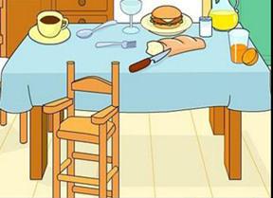[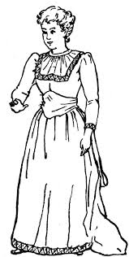](http://www.google.com/imgres?imgurl=http://etc.usf.edu/clipart/3800/3861/woman_8_lg.gif&imgrefurl=http://etc.usf.edu/clipart/3800/3861/woman_8.htm&h=1024&w=516&tbnid=elNEw_-FxxcHAM:&zoom=1&docid=pgKQOjb-pQ-kyM&ei=kPOjU46TIoqh4gTo9oCoCQ&tbm=isch&ved=0CE8QMyhHMEc4ZA&iact=rc&uact=3&dur=452&page=6&start=165&ndsp=35)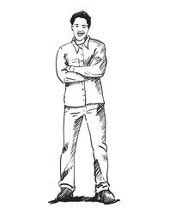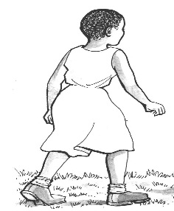 Joan Peter Mary

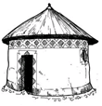

**Write the right preposition.**

1. Peter is Joan and Mary.

2. Joan is on the of Peter.

3. Mary is on the of Peter.

4. A tree is the house.

5. The house is of the tree.

6. The chair is of the table.

7. The table is the boy.

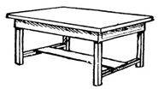**Fill in the blanks within, on, under, near, behind, and between.**

8. The tin is the table.



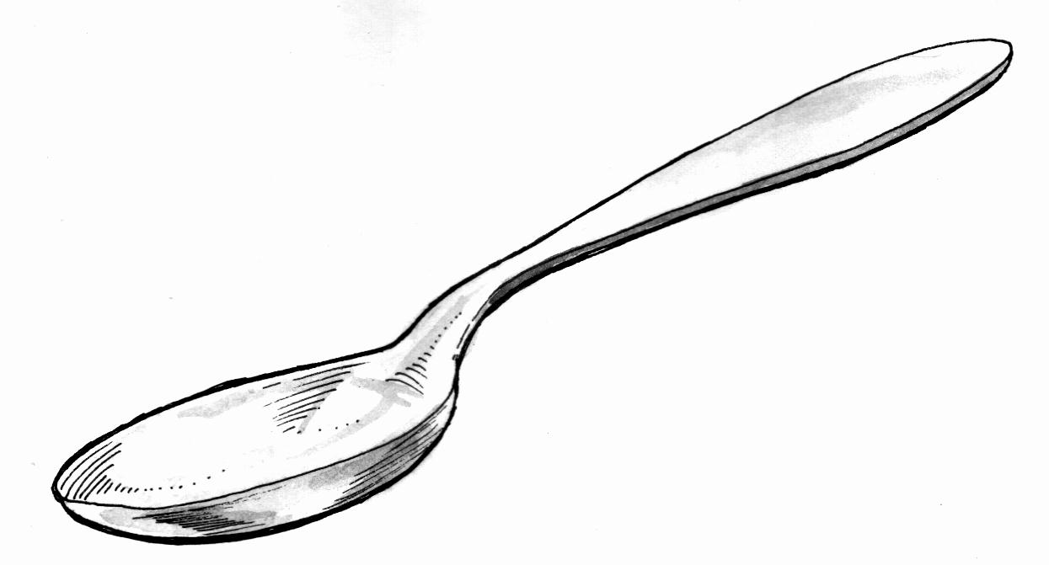9. A spoon is the plate.



**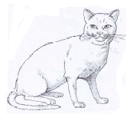**10. A cat is the table.

Corrections

***Score strip***

Name: \_\_\_\_\_\_\_\_\_\_\_\_\_\_\_\_\_\_\_\_\_\_\_\_\_\_\_\_\_\_\_\_\_\_\_\_\_\_\_\_\_

Date: \_\_\_\_\_\_\_\_\_\_\_\_\_\_\_\_\_\_\_\_\_\_\_\_\_\_\_\_\_\_\_\_\_\_\_\_\_\_\_\_\_\_

Spellings Corrections

1. 1.

2. 2.

3. 3.

4. 4.

5. 5.

**Forming plurals on nouns by adding “s”** e.g. pencil-pencils.

Singular means one and plural means many. **Tick in the box next to each correct answer and write the answer.**

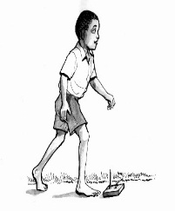1. Here are two

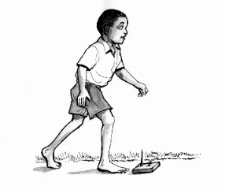 boy

boyes

boys

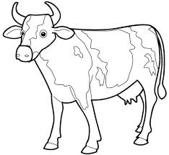2. The farmer had only one

cow

cowes

cows

3. Here are some

rose

roses

rosed

[](https://www.google.com/search?tbm=isch&q=an+apple+drawing&revid=1119174270)4. Here are some

apples

[](https://www.google.com/search?tbm=isch&q=an+apple+drawing&revid=1119174270) apple

appled

5. Let’s sit on this

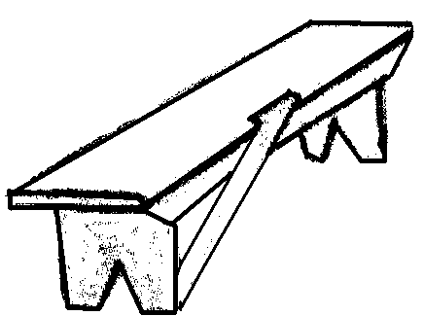 benches

benchs

bench

**Circle the word that names each picture. Then write the word on the line.**

|  |  |  |
| --- | --- | --- |
| D:\MY PHOTOZ\Photoes\Goat-6.jpgD:\MY PHOTOZ\Photoes\Goat-6.jpg  goat goats | tree trees | bridge bridges |
| flower flowers | tennis-clipart-black-and-white-shoe-clip-art_1404137009  shoe shoes | cloud clouds |

2

broom

\_\_\_

1

star

stars

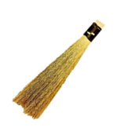



4

\_banana\_\_\_\_\_

3

telephone



dglxasset[1]dglxasset[1]dglxasset[1]

5

umbrella

6

carrot

dglxasset[1]

***Score strip***

Name: \_\_\_\_\_\_\_\_\_\_\_\_\_\_\_\_\_\_\_\_\_\_\_\_\_\_\_\_\_\_\_\_\_\_\_\_\_\_\_\_\_

Date: \_\_\_\_\_\_\_\_\_\_\_\_\_\_\_\_\_\_\_\_\_\_\_\_\_\_\_\_\_\_\_\_\_\_\_\_\_\_\_\_\_\_

School: \_\_\_\_\_\_\_\_\_\_\_\_\_\_\_\_\_\_\_\_\_\_\_\_\_\_\_\_\_\_\_\_\_\_\_\_\_\_\_\_\_

Spellings Corrections

1. 1.

2. 2.

3. 3.

4. 4.

5. 5.

**Activity**

Are these / those ?

Yes, they are/ no, they are not.

[](http://www.clipartof.com/portfolio/nlshop/illustration/seedling-plants-by-a-piece-of-paper-over-green-97180.html)1 . Are these brooms?

**No, they are not.**

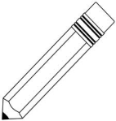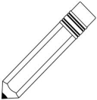

2. . Are these books?

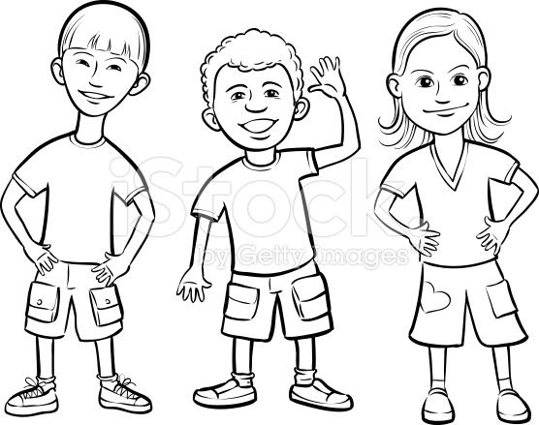

3. Are these children?

MC900128887[1]MC900128887[1]

4. Are those flags?

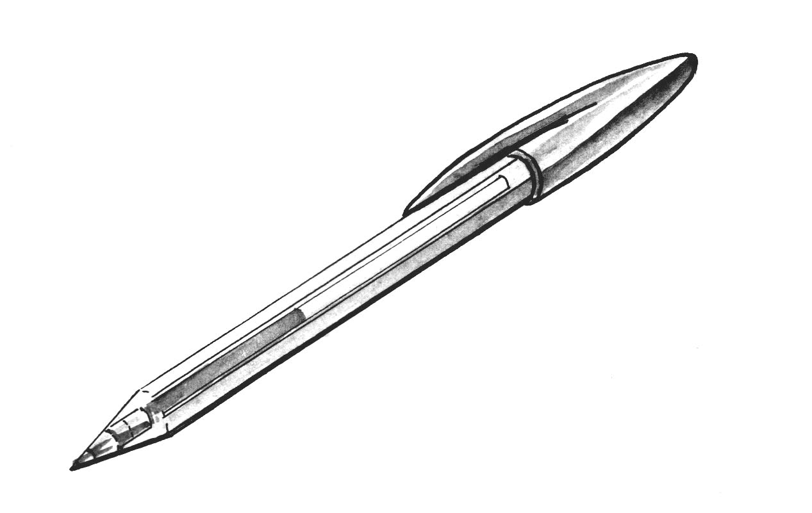5.

Are those pens?



6. Are these trees?

7. Are these books?



8. Are those uniforms?

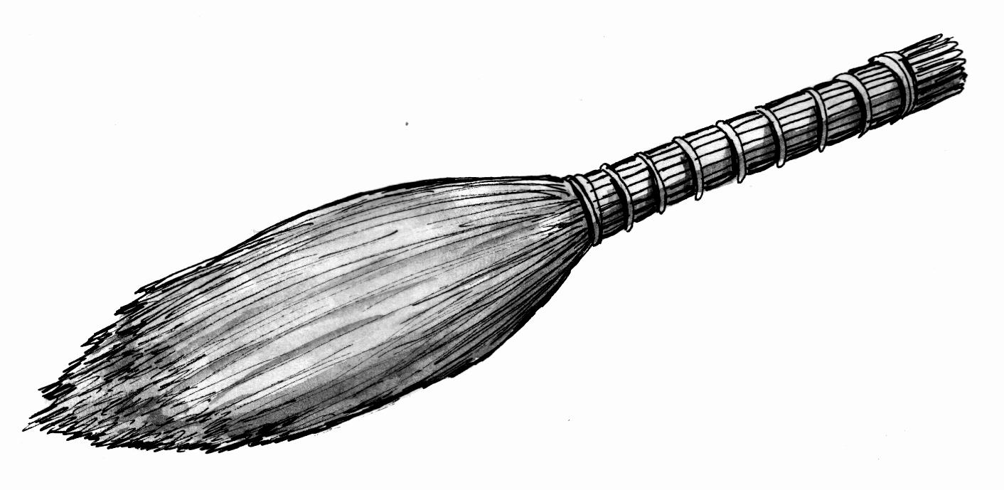

9. Are those brooms?



10. Are these +tables?

Homophones

Hall - whole , hole

Steal - still , steel

Ball - bowl

Blue - blew

Corrections

***Score strip***

 Checkup 1

Supervisor’s initial \_\_\_\_\_\_\_\_\_\_\_\_

Score \_\_\_\_\_\_\_\_\_\_\_\_\_\_\_\_\_\_\_\_

Supervisor’s comment \_\_\_\_\_\_\_\_\_\_\_\_\_\_\_\_\_\_\_\_\_\_\_\_

**PROJECT WORK** (Do it in groups of three)

Using a hard box, cut out shapes and build a house with the knowledge of prepositions e.g. The triangle is **on** the rectangleand construct other prepositions of the house.

on

**Required shapes**

Square(2) triangle(roof) rectangle

Rectangle (2) square (roof) (window)

Triangle Circle \_ Rectangle(door)

|  |  |  |  |  |
| --- | --- | --- | --- | --- |
| **WEEK** | **VALUE PROMISE** | **MEMORY VERSE** | **CHARACTER TRAITS** | **WORK HABIT** |
| **THREE** | “I will always be true and do the right things”. | 1st Timothy 4:12 | 1. Be of great integrity & dignity  2. Be truthful  3. Be genuine  4. Endurance & honesty  5. Be bold | Be gentle to all and stern to all |

1st Timothy 4:12 “Do not let anyone look down on you because you are young, but be an example for the believers in your speech your conduct, your love, faith and purity”.

Work habit

Name: \_\_\_\_\_\_\_\_\_\_\_\_\_\_\_\_\_\_\_\_\_\_\_\_\_\_\_\_\_\_\_\_\_\_\_\_\_\_\_\_\_

Date: \_\_\_\_\_\_\_\_\_\_\_\_\_\_\_\_\_\_\_\_\_\_\_\_\_\_\_\_\_\_\_\_\_\_\_\_\_\_\_\_\_\_

School: \_\_\_\_\_\_\_\_\_\_\_\_\_\_\_\_\_\_\_\_\_\_\_\_\_\_\_\_\_\_\_\_\_\_\_\_\_\_\_\_\_

Spellings Corrections

1. 1.

2. 2.

3. 3.

4. 4.

5. 5.

We add “es” to singular nouns that end in ss, sh, ch and x to make them plural.

|  |  |
| --- | --- |
| **Singular** | **Plural** |
| glass | glasses |
| church | churches |
| dish | dishes |
| tax | taxes |

Activity

Make the given words plural.

2

box

Watches

1

watch

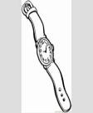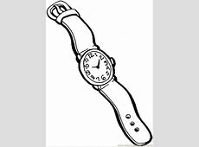

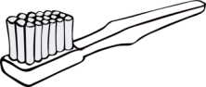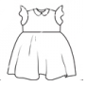

4

Dress

3

Toothbrush



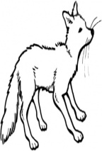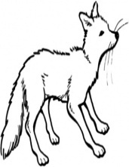

6

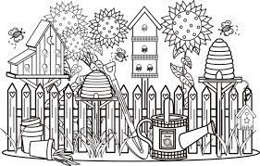

Bush

5

Fox

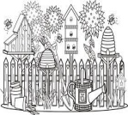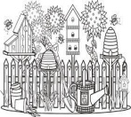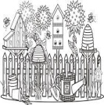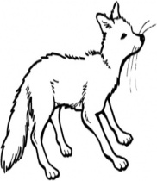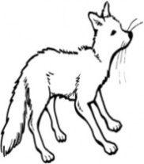

**Give the plural of the underlined word.**

1. She broke the glass.

2. Oxygen is a gas.

3. The lady has a blue dress.

4. A bitch is a female dog.

5. You need a torch to light in the dark.

6. Dad brought home a bunch of grapes.

7. The poetess is known all over the world.

8. The tree has one branch.

9. The hunter shot at the buffalo.

10. The playful boy fell into a ditch.

***Score strip***

Name: \_\_\_\_\_\_\_\_\_\_\_\_\_\_\_\_\_\_\_\_\_\_\_\_\_\_\_\_\_\_\_\_\_\_\_\_\_\_\_\_\_

Date: \_\_\_\_\_\_\_\_\_\_\_\_\_\_\_\_\_\_\_\_\_\_\_\_\_\_\_\_\_\_\_\_\_\_\_\_\_\_\_\_\_\_

School: \_\_\_\_\_\_\_\_\_\_\_\_\_\_\_\_\_\_\_\_\_\_\_\_\_\_\_\_\_\_\_\_\_\_\_\_\_\_\_\_\_

Spellings Corrections

1. 1.

2. 2.

3. 3.

4. 4.

5. 5.

**Poem**

Read the poem and answer questions that follow in full sentences.

**MY CLASS**

P.2 yellow is a model class

With all I need to learn well

A chalkboard, chair, table and desks

Pencils and colours

I use to write a and shade

Then a library full of story books

Which I read in my free time

Oh! P.2 yellow, you are the best class of all

Questions

1. In which class is the writer?

2. What does the writer use to write?

3. The writer sits on the;

4. What is the best class of all?

5. What is the title of the poem?

**School ! School ! School !**

Teachers at school !

Cooks at school.

Head teacher at school.

Nurse at school

Our beloved place to learn from

We use pens, books, pencils and rulers at school

Offices, classes, kitchen, toilets,

Dining halls are buildings found at school

Questions

1. What is the poem about?

2. Name the people found at school according to the poem.

i)

ii)

3. Mention the things we use at school.

i) iii)

ii) iv)

4. Who wrote the poem?

5. Write the building found at school.

i) iii)

ii) iv)

***Score strip***

Name: \_\_\_\_\_\_\_\_\_\_\_\_\_\_\_\_\_\_\_\_\_\_\_\_\_\_\_\_\_\_\_\_\_\_\_\_\_\_\_\_\_

Date: \_\_\_\_\_\_\_\_\_\_\_\_\_\_\_\_\_\_\_\_\_\_\_\_\_\_\_\_\_\_\_\_\_\_\_\_\_\_\_\_\_\_

Spellings Corrections

1. 1.

2. 2.

3. 3.

4. 4.

5. 5.

**Plurals with “ies”.**

**Some words which end with “y” we change “y” to “I” and then we add es.**

Examples

Lady – ladies

Baby – babies

**Activity**

**1. Drop “y” and “ies” to make the nouns below plural.**

Lady

Puppy

Family

Body

Butterfly

City

Story

Party

Society

**2. Give the plural of the bolded noun.**

1. There is a **fly** on the wall.

2. I heard a **cry** in the cave.

3. They will have a **party** next week.

4. Kampala is a **city**.

5. You have to take care of the **baby.**

6. A **daisy** is a flower.

7. The **lorry** is stuck in the mud.

8. The **factory** is busy.

9. The pupils had a long **study** of the area.

10. Sheila is a beautiful **lady.**

Corrections

***Score strip***

Date :\_\_\_\_\_\_\_\_\_\_\_\_\_\_\_\_\_\_\_\_\_\_\_\_\_\_\_\_\_\_\_\_\_\_\_\_\_\_\_\_\_

Name: \_\_\_\_\_\_\_\_\_\_\_\_\_\_\_\_\_\_\_\_\_\_\_\_\_\_\_\_\_\_\_\_\_\_\_\_\_\_\_\_\_

**Adding “s” to nouns which end with “y”**

Examples

boy - boys

key - keys

trays - trays

day -

valley -

toy -

**Change the given words to plurals to complete the sentences.**

1. Teacher’s are on the table.(key)
2. like bananas. (monkey)
3. The are on the lorry.(turkey)
4. like playing football.(boy)
5. We are going to swim for two (day)
6. Our aunt from London. (toy)
7. There are many houses in the (valley)

***Score strip***



Name: \_\_\_\_\_\_\_\_\_\_\_\_\_\_\_\_\_\_\_\_\_\_\_\_\_\_\_\_\_\_\_\_\_\_\_\_\_\_\_\_\_

Date: \_\_\_\_\_\_\_\_\_\_\_\_\_\_\_\_\_\_\_\_\_\_\_\_\_\_\_\_\_\_\_\_\_\_\_\_\_\_\_\_\_\_

Spellings Corrections

1. 1.

2. 2.

3. 3.

4. 4.

5. 5.

**Plural with “ves”.**

Words that end with “f”/“fe” in them we change “f”/“fe” to “v” and we add es.

Examples.

|  |  |
| --- | --- |
| knife | knives |
| loaf | loaves |
| wolf | wolves |
| shelf | shelves |
| calf | calves |
| wife | wives |
| thief | thieves |

**Activity**

**Fill in the plural of the word in the bracket.**

1. There are ten on the table. (leaf)

2. The books are kept in the . (shelf)

3. were taken to the police station. (thief)

4. My father brought two of bread. (loaf)

5. Our cow produced three . (calf)

Fill in the gaps.

My name is .

I am years old.

I am in grade .

I go to school at .

My class teacher is called .

I like learning .

**Read the poem.**

It’s time to go back to school.

All the boys and girls.

Carry colours, pencils, many books.

Shouting and reading words.

It’s fun to count and sing.

It’s fun to draw and point.

We learn to play and pray.

We learn to stand and sit.

**Questions**

1. What do the boys and girls carry to school?

2. The children are shouting and words.

3. It’s fun to and write.

4. It’s fun to draw and .

5. We learn to and sit.

Corrections

***Score strip***

 Checkup 2

Supervisor’s initial \_\_\_\_\_\_\_\_\_\_\_\_

Score \_\_\_\_\_\_\_\_\_\_\_\_

Supervisor’s comment \_\_\_\_\_\_\_\_\_\_\_\_\_\_\_\_\_\_\_\_\_\_\_\_\_\_

**PROJECT WORK**

Look around your class and give the plural of twelve objects in your class. Name and draw them.

|  |  |  |  |  |
| --- | --- | --- | --- | --- |
| **WEEK** | **VALUE PROMISE** | **MEMORY VERSE** | **CHARACTER TRAITS** | **WORK HABIT** |
| **FOUR** | “I choose to do what glorifies the Lord”. | Mathew 7:12 | 1. Be tender & considerate  2. Be loving  3. Be just & kind  4. Be truthful & peaceful  5. Avoid favoritism and being judgmental | Be kind whenever possible. It is always possible |

Mathew 7:12 “Do for others what you would wish them to do for you”.

Work habit

Name: \_\_\_\_\_\_\_\_\_\_\_\_\_\_\_\_\_\_\_\_\_\_\_\_\_\_\_\_\_\_\_\_\_\_\_\_\_\_\_\_\_

Date: \_\_\_\_\_\_\_\_\_\_\_\_\_\_\_\_\_\_\_\_\_\_\_\_\_\_\_\_\_\_\_\_\_\_\_\_\_\_\_\_\_\_

School: \_\_\_\_\_\_\_\_\_\_\_\_\_\_\_\_\_\_\_\_\_\_\_\_\_\_\_\_\_\_\_\_\_\_\_\_\_\_\_\_\_

Spellings Corrections

1. 1.

2. 2.

3. 3.

4. 4.

5. 5.

**Activity**

**Write these words correctly.**

ngu

licepo

neighoodbourh

eachert

nuser

ndla

laburo

sericuty

terwa

**Structures**

**What you like? Or what don’t you like?**

**Use Yes, I do or No, I don’t.**

1. Do you like a thief?

2. Do you like a gun?

3. Do you like a uniform?

4. Do you like fighting?

5. Do you like stealing?

6. Do you like to go to the police?

7. Do you like colour blue?

8. Do you like colour green?

9. Would you like to be a policeman?

Corrections

***Score strip***

**Plurals of irregular nouns which don’t change**

**Examples**

|  |  |
| --- | --- |
| Singular plural | Singular plural |
| Sheep sheep  Deer deer  Furniture furniture | fish fish  trout trout  salmon salmon |

**Fill in correctly.**

1. An old is bleating from the stable (ship, sheep)

2. There is a in the aquarium. (bird, fish)

3. He made from wood (chairs, furniture)

4. are water animals. (lions, fish)

5. are water birds. (goose, geese)

**Give the plural of the underlined words.**

Sheep

Deer

Furniture

Fish

Trout

***Score strip***

Name: \_\_\_\_\_\_\_\_\_\_\_\_\_\_\_\_\_\_\_\_\_\_\_\_\_\_\_\_\_\_\_\_\_\_\_\_\_\_\_\_\_

Date: \_\_\_\_\_\_\_\_\_\_\_\_\_\_\_\_\_\_\_\_\_\_\_\_\_\_\_\_\_\_\_\_\_\_\_\_\_\_\_\_\_\_

Spellings Corrections

1. 1.

2. 2.

3. 3.

4. 4.

5. 5.

Activity

**Write the words correctly.**

therbro

ntau

ghterdua

relavesti

faerth

ons

ldchi

lyfami

thermo

byba

cleun

**Construct the sentences from the pictures below.**

|  |
| --- |
| Related imageRelated image |
| C:\Users\Esther\AppData\Local\Microsoft\Windows\Temporary Internet Files\Content.Word\scan0046.jpgC:\Users\Esther\AppData\Local\Microsoft\Windows\Temporary Internet Files\Content.Word\scan0046.jpg |
| C:\Users\DELL\Desktop\NEW GALLERY\sorry\stories\fairytale-oldwoman_IS.jpg  C:\Users\user\Desktop\man.png |
| Big Sister Coloring Pages: Big Sister Coloring Pages Free Download ... |
|  |

**Fill in the missing letters.**

|  |  |  |  |
| --- | --- | --- | --- |
| f \_\_ ther | m \_\_\_ ther | a \_\_\_ nt | un \_\_\_ le |
| so \_\_\_\_\_ | s \_\_\_ ter | b \_\_\_ other | b \_\_\_ by |

**Activity III**

Reciting the rhyme

A RHYME

Grandfather and grand mother

You are like no other

You had mum and dad

And I am so glad

Yes, it is not bad

That is not all you had

You also had uncles and aunties to

Who are as lovely as you

By Annet

Questions

1. What is the rhyme about?

2. How many people are in the rhyme?

3. Who wrote the rhyme?

4. Draw your grandmother and grandfather.

|  |  |
| --- | --- |
|  |  |

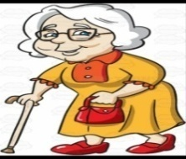5. Who is this?

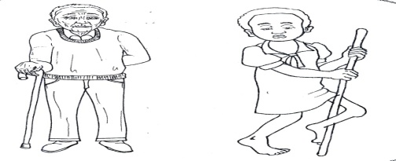

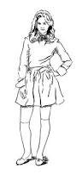This is my This is my

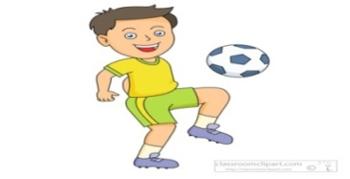This is a He is my

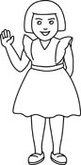

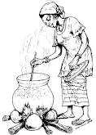She is my He is my

Who are these?

These are my Those are my

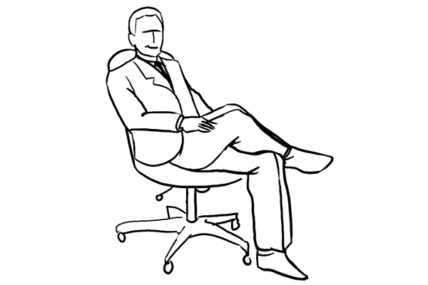mother.png

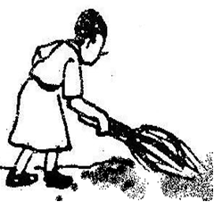

***Score strip***

**Study those relationships among family members.**

1. The mother to your father/mother is your grandmother.

2. The father to your father/mother is your grandfather.

3. The woman who produced you is your mother.

4. The sister to your mother or father is your aunt.

5. A brother to your mother or father is your uncle.

6. A boy child to your family is a son.

7. A girl child to your family is your daughter.

8. A child of your aunt or uncle is your cousin.

9. The son of your sister or brother is your nephew.

10. The daughter of your sister or brother is your niece.

**Complete the sentences.**

The mother of your mother is your

A boy child of your family is your

A sister to your father is your

The child of your aunt is your

**Give the opposites of the underlined words.**

1. This is a girl.

2. My mother is sick.

3. He is my uncle.

4. Mrs. Kintu is my grandmother.

5. Mary is my daughter.

6. That man is mad.

7. My brother fetches water.

8. She is my niece.

9. It is too cold.

10. My wife is short.

Corrections

***Score strip***

Word index

My school

|  |  |
| --- | --- |
| Word | Meaning |
| 1. Study | The devotion of time and attention to gaining knowledge. |
| 2. Daisy | Flower given to congratulate new mother. |
| 3. Party | A social gathering of invited guests, typically, involving eating, drinking and entertainment. |
| 4. Celebration | The action of celebrating an important day or event. |
| 5. Factory | A building where goods are manufactured directly by machine. |
| 6. City | A large town. |
| 7. Shelf | Flat length of wood attached to a wall that provides surface for the storage or display of objects. |
| 8. Wolf | A ferocious animal. |
| 9. Loaf | A quantity of bread that is shaped and baked in one piece and usually sliced before being eaten. |
| 10. Security | The state of being free from danger or threat. |

Homophones

Aunt ant

Uncle ankle

Father farther further

Son sun

Study Mr. Lwasa’s family and answer the questions about it.

Mr. Lwasa

Miss Nakityo

Monica Aaron

Resty

Aaron





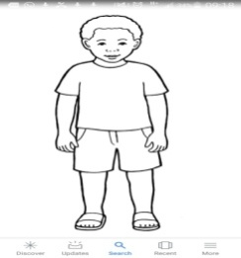

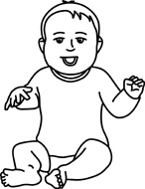

Questions

1. Whose family is shown?

2. How many members are in Mr. Lwasa’s family?

3. How many boys are in Mr. Lwasa’s family?

4. What is the name of the baby?

5. What is the name of Mr. Lwasa’s wife?

6. What is the name of the girl?

7. Name the members in Mr. Lwasa’s family.

i) iii)

ii) iv)

Other words

|  |  |
| --- | --- |
| Word | Meaning |
| barn | A large farm building used for storing grain, hay, or straw or for housing livestock. |
| naughty | Badly behaved and disobedient. |
| mice | Rodents with pointed shouts. |
| collect | Bring or gather together. |
| scrub | Rub hard so as to clean them, typically with a brush and water. |
| tasty | Having a pleasant, distinct flavor. |
| hut | A small, simple, single-storey house or shelter. |
| hurt | Cause pain or injury to. |
| hat | A shaped covering for the head worn for warmth. |
| cunning | Having or showing skill in achieving one’s end by deceit or evasion. |

***Score strip***



Checkup 3

Supervisor’s initial \_\_\_\_\_\_\_\_\_\_\_\_

Score \_\_\_\_\_\_\_\_\_\_\_\_\_\_\_\_\_\_\_\_

Supervisor’s comment \_\_\_\_\_\_\_\_\_\_\_\_\_\_\_\_\_\_\_\_\_\_\_\_\_\_\_\_\_

**PROJECT WORK**

Get a paper and write the name of your role model, why you like her and how she inspires you.

|  |  |  |  |  |
| --- | --- | --- | --- | --- |
| **WEEK** | **VALUE PROMISE** | **MEMORY VERSE** | **CHARACTER TRAITS** | **WORK HABIT** |
| **FIVE** | “I will always do good to others the way I want them to do for me”. | Proverbs 31: 25 | 1. Be strong and of great dignity  2. Do not be fearful  3. Always work without ceasing  4. Rejoice in the lord and be thankful.  5. Be helpful | Believe you can and you’re halfway there |

Proverbs 31: 25 “She is strong and of dignity; she is not afraid of the future”.

Work habit

Name: \_\_\_\_\_\_\_\_\_\_\_\_\_\_\_\_\_\_\_\_\_\_\_\_\_\_\_\_\_\_\_\_\_\_\_\_\_\_\_\_\_

Date: \_\_\_\_\_\_\_\_\_\_\_\_\_\_\_\_\_\_\_\_\_\_\_\_\_\_\_\_\_\_\_\_\_\_\_\_\_\_\_\_\_\_

School: \_\_\_\_\_\_\_\_\_\_\_\_\_\_\_\_\_\_\_\_\_\_\_\_\_\_\_\_\_\_\_\_\_\_\_\_\_\_\_\_\_

Spellings Corrections

1. 1.

2. 2.

3. 3.

4. 4.

5. 5.

**A pronoun** is a word that is used in place of a noun.

Mukul is good at studies. He stands first in class

The word he stands for the noun Mukulu

The word he is a pronoun

Learn these pronouns

|  |  |  |  |
| --- | --- | --- | --- |
| I  Me  We  Us | you | He  Him  they | She  It  Her  Them |

**Underline the pronouns in the sentences.**

1. We can win this match.

2. Grandma told her a story.

3. I met him in the bus.

4. Do you want us to stay?

5. Pick your shirt and put it in the cupboard.

6. The boys are hungry. Give them some sandwiches.

7. He wished the teacher and she smiled back.

8. They have lived here for years.

9. The old man asked me to help him cross the road.

10. I gave the cat some milk and it drank it all up.

He, she, it and are subject pronouns. They can take the place of naming words.

Write he, she or it to take the place the underlined words.

Corrections

***Score strip***

**Guided composition**

**Use the words in the box to complete the sentences on child rights.**

Shelter play health care food education

|  |
| --- |
| MC900436129[1]1. Children must go to school  This is the right to |

|  |
| --- |
| **C:\Users\LG COMPUTERS\Desktop\NEW GALLERY\sorry\stories\eating.jpg**  2. All children should get enough to eat.  This is the right to |
| 3. Children should not work all the time.  Together with their friends they have  a right to |
| **C:\Program Files\Microsoft Office\CLIPART\PUB60COR\J0105710.WMF**  4. Children need houses to keep them  warm and safe.  This is the right to |
| **ANd9GcTWigslOwEgPARSY9Z3I9q3wz-qo5iQBVg5h3nnkSaKpfpnOFPN**  5. Sick children have the  right to |

**Picture interpretation**

**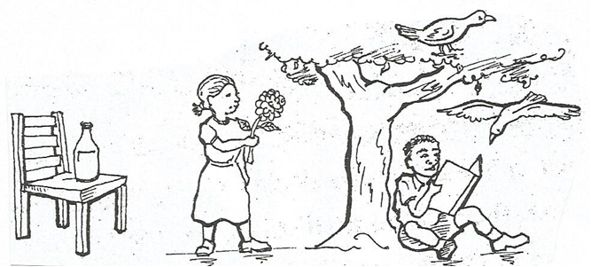Study the picture and write sentences about the picture.**

1.

2.

3.

4.

5.

Corrections

***Score strip***

Date: \_\_\_\_\_\_\_\_\_\_\_\_\_\_\_\_\_\_\_\_\_\_\_\_\_\_\_\_\_\_\_\_\_\_\_\_\_\_\_\_\_

Name: \_\_\_\_\_\_\_\_\_\_\_\_\_\_\_\_\_\_\_\_\_\_\_\_\_\_\_\_\_\_\_\_\_\_\_\_\_\_\_\_

Class: \_\_\_\_\_\_\_\_\_\_\_\_\_\_\_\_\_\_\_\_\_\_\_\_\_\_\_\_\_\_\_\_\_\_\_\_\_\_\_\_\_

**Punctuation marks.**

**Capital letters and full stops.**

Capital letters are those letters of the alphabet that are written or printed in the form, which is used at the beginning of a sentence or names. Look at the letters below.

A,B,C,D,E,F,G,H,I,J,K,L,M,N,O,P,Q,R,S,T,U,V,W,X,Y,Z

Capital letters are used in the following cases

1. At the beginning of every sentence e.g. we shall come tomorrow.

2. At the first word of every line of a verse, for example,

**Oh, AIDS why do you kill us!**

**When will you stop it?**

**We still need our life.**

3. At the beginning of direct quotation e.g. Mary said “I will kill it”.

4. All proper nouns e.g. Rwanda, Kenyan, Kilimanjaro, Rwenzori, October, John and so on

5. Pronoun I

6. For titles used before proper nouns, for example, doctor Moses Ali, Sir Albert Cook.

**ACTIVITY**

**Punctuation**

**Read the sentences. Colour in the bubble under the correct end mark for each sentence.**

1. Where did I put my shoes

**.** ? !

2. The frog was in the pond

**.**  ? !

3. Do you want a pet

**.** ? !

4. Jane has a cat

. ? !

5. What a big fish

. ? !

***Score strip***

Name: \_\_\_\_\_\_\_\_\_\_\_\_\_\_\_\_\_\_\_\_\_\_\_\_\_\_\_\_\_\_\_\_\_\_\_\_\_\_\_\_\_

Date: \_\_\_\_\_\_\_\_\_\_\_\_\_\_\_\_\_\_\_\_\_\_\_\_\_\_\_\_\_\_\_\_\_\_\_\_\_\_\_\_\_\_

Spellings Corrections

1. 1.

2. 2.

3. 3.

4. 4.

5. 5.

**Rewrite and punctuate the sentences below with the right punctuation marks.**

1. Tuesday 11 1999

2. that’s good advice isn’t it

3. have tonny and sarah married yet

4. there are many islands in the Indian ocean

5. I will come tomorrow said john

6. teddy brought a pen books pencils and a bag

7. sir Edward muteesa died in Britain

8. lake view senior secondary school,

p.o. box 1141,

Nairobi

9. her father in law died yesterday

10. i wonder whether he is still alive

11. Jesus apostles were twelve in number

12. dr sam achebe was a Nigerian citizen

13. Does mrs adams own a car asked james

Name: \_\_\_\_\_\_\_\_\_\_\_\_\_\_\_\_\_\_\_\_\_\_\_\_\_\_\_\_\_\_\_\_\_\_\_\_\_\_\_\_\_

Date: \_\_\_\_\_\_\_\_\_\_\_\_\_\_\_\_\_\_\_\_\_\_\_\_\_\_\_\_\_\_\_\_\_\_\_\_\_\_\_\_\_\_

Spellings Corrections

1. 1.

2. 2.

3. 3.

4. 4.

5. 5.

**Rewrite these sentences using capital letters, full stops or question marks where necessary.**

1. The dog barked at the stranger

The dog barked at the stranger.

2. my cousin and I study in the same class

3. How did you get your shirt so dirty

4. Why did the greedy fox praise the cow

5. Who is the boy sitting next to esther

6. India and nepal are neighbours

7. One and one makes two

8. Which of these dresses do you like

**Capitalizing names**

Sometimes the names of people places and things are special they begin with capital letters

Circle the special names in the picture. Write each correctly on a line

i) iii)

ii) iv)

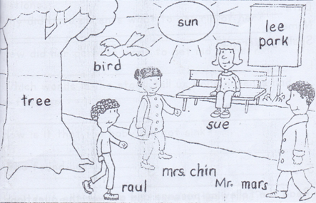

***Score strip***

 Checkup 4

Supervisor’s initial \_\_\_\_\_\_\_\_\_\_\_\_\_

Score \_\_\_\_\_\_\_\_\_\_\_\_\_\_\_\_

Supervisor’s comment \_\_\_\_\_\_\_\_\_\_\_\_\_\_\_\_\_\_\_\_\_\_\_\_\_\_\_

**PROJECT WORK**

Name of these family members at home using capital letters

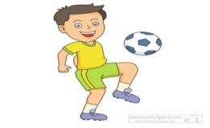

5

3

4

2

1



mother.png

|  |  |  |  |  |
| --- | --- | --- | --- | --- |
| **WEEK** | **VALUE PROMISE** | **MEMORY VERSE** | **CHARACTER TRAITS** | **WORK HABIT** |
| **SEVEN** | “I choose to be at peace and have good team work”. | Psalm 127:3-5 | 1. Be responsible  2. Be God fearing  3. Be compassionate to your children  4. Be obedient & respect for children  5. Cherish the glory of your children | Discipline is the bridge between goals and accomplishment |

Psalm 127:3-5 “Children are a gift from the lord, they are a real blessing like arrows in the hands of a warrior, are children born in one’s youth”.

Work habit

Name: \_\_\_\_\_\_\_\_\_\_\_\_\_\_\_\_\_\_\_\_\_\_\_\_\_\_\_\_\_\_\_\_\_\_\_\_\_\_\_\_\_

Date: \_\_\_\_\_\_\_\_\_\_\_\_\_\_\_\_\_\_\_\_\_\_\_\_\_\_\_\_\_\_\_\_\_\_\_\_\_\_\_\_\_\_

School: \_\_\_\_\_\_\_\_\_\_\_\_\_\_\_\_\_\_\_\_\_\_\_\_\_\_\_\_\_\_\_\_\_\_\_\_\_\_\_\_\_

Spellings Corrections

1. 1.

2. 2.

3. 3.

4. 4.

5. 5.

**Read the following passage and answer the questions that follow in full sentences.**

**LOI**

Loi was born of poor parents who were starving at the time of her birth as they were too poor to bring up the baby, they thought of throwing her into the river that flowed near their village. They went to do so but they had no courage to throw her into the water so they wrapped the child into a Loi or a poor man’s coarse woolen cloth. Then they put her into a wooden basket and set it to float on the river.

The basket floated on and on until it reached a place where a holy man was taking a bath in the river. Out of curiosity he got hold of the basket and was surprised to see in it a child.

He took pity on the little girl and brought her up as his own child. He named her Loi after the woolen cloth she had found her in.

**Questions**

1. Why did Loi’s parents want to get rid of her?

2. How did her parents want to get rid of her?

3. Which words in the story tell us Loi’s parents had kind feelings.

4. How is it that the baby did not sink?

5. Who found her?

6. How did he happen to be there at that time?

7. Why was the baby called Loi?

8. Who called her that name?

***Score strip***

Name: \_\_\_\_\_\_\_\_\_\_\_\_\_\_\_\_\_\_\_\_\_\_\_\_\_\_\_\_\_\_\_\_\_\_\_\_\_\_\_\_\_

Date: \_\_\_\_\_\_\_\_\_\_\_\_\_\_\_\_\_\_\_\_\_\_\_\_\_\_\_\_\_\_\_\_\_\_\_\_\_\_\_\_\_\_

School: \_\_\_\_\_\_\_\_\_\_\_\_\_\_\_\_\_\_\_\_\_\_\_\_\_\_\_\_\_\_\_\_\_\_\_\_\_\_\_\_\_

Spellings Corrections

1. 1.

2. 2.

3. 3.

4. 4.

5. 5.

**New words**

|  |  |  |  |
| --- | --- | --- | --- |
| walk | write | pray | run |
| seep | dance | cook |  |
| clean | play | sing |  |
| wash | comb | eat |  |

**Make correct sentences using the following.**

sweep

dance

comb

pray

wash

clean

**Arrange these sentences to make a good story.**

He fell down and cried

He saw a mango tree with ripe mangoes

He put his bag down to climb the tree

As he reached the ripe mangoes

As john was going to school

**A good story**

a)

b)

c)

d)

e)

Corrections

**Guided composition**

**Choose the correct words from the table and fill in the blank space.**

We are good children at school. Good children look every time. We need and to bathe. Bathing helps us to be clean and healthy. We brush our teeth using and cut our fingernails using a

. Before going to school, we and

our room. We are very good children.

mop, toothbrush, smart, sweep, soap, water, nail cutter

Corrections

***Score strip***

Name: \_\_\_\_\_\_\_\_\_\_\_\_\_\_\_\_\_\_\_\_\_\_\_\_\_\_\_\_\_\_\_\_\_\_\_\_\_\_\_\_\_

Date: \_\_\_\_\_\_\_\_\_\_\_\_\_\_\_\_\_\_\_\_\_\_\_\_\_\_\_\_\_\_\_\_\_\_\_\_\_\_\_\_\_\_

School: \_\_\_\_\_\_\_\_\_\_\_\_\_\_\_\_\_\_\_\_\_\_\_\_\_\_\_\_\_\_\_\_\_\_\_\_\_\_\_\_\_

Spellings Corrections

1. 1.

2. 2.

3. 3.

4. 4.

5. 5.

**Present continuous tense (now tense)**

**Key words**

is are am now

**Examples**

wash - washing

eat - eating

kick - kicking

**Change these verbs to present continuous tense.**

work sing

finish test

walk make

pray clean

fetch sit

beat wash

go kick

watch look

do call

ask milk

read

**Match the following activities with items used.**

|  |  |
| --- | --- |
| bathing | slasher |
| ironing | sponge |
| slashing | flat iron |
| washing | broom |
| Sweeping | soap |

**Answer the questions in full sentences.**

1. What do you use to cut your fingernails?

2. What do you use to brush your teeth?

3. What do you use to polish your shoes?

4. What do you use to wash your clothes?

5. What do you use to comb your hair?

6. What do you use to iron your clothes?

**Use the words in the brackets correctly.**

1. Water is from a hole in the can. (drop)

2. The rude boy is the door. (slam)

3. The garden is busy the hedge.(him)

4. Mummy is meat now. (cook)

5. We are going for now. (swim)

6. Grandmother is the garden now.(dig)

7. The children are the apples in the basket. (put)

8. Joy is the bathroom now. (scrub)

9. We are to go to town (plan)

10. The boys are in Namboole now. (run)

Corrections

***Score strip***

 Checkup 5

Supervisor’s initial \_\_\_\_\_\_\_\_\_\_\_\_\_

Score \_\_\_\_\_\_\_\_\_\_\_\_\_\_\_\_\_\_\_\_\_

Supervisor’s comment \_\_\_\_\_\_\_\_\_\_\_\_\_\_\_\_\_\_\_\_\_\_\_\_

**PROJECT WORK**

1 a) What is personal hygiene?

b) Name and draw the items that help you to promote personal hygiene.

|  |  |  |  |
| --- | --- | --- | --- |
|  |  |  |  |
|  |  |  |  |

**2. Rewrite the sentences using present continuous tense.**

a) I saw Kyla wash her uniform last night.

b) Priscilla loves to do house chores.

|  |  |  |  |  |
| --- | --- | --- | --- | --- |
| **WEEK** | **VALUE PROMISE** | **MEMORY VERSE** | **CHARACTER TRAITS** | **WORK HABIT** |
| **EIGHT** | “I believe God will always help me to be a good leader”. | Mathew 20 : 27 -28 | 1. Be a good leader  2. Do not be judgmental  3. Be kind and patient  4. Seeks God’s approval always  5. Be responsible | Discipline is what you must have to resist the lies of excuses |

Mathew 20 : 27 -28 “And whoever would be first among you must be your slave, even as the son of man came not to be served but to serve and to give life as a ransom for many”.

Work habit

Name: \_\_\_\_\_\_\_\_\_\_\_\_\_\_\_\_\_\_\_\_\_\_\_\_\_\_\_\_\_\_\_\_\_\_\_\_\_\_\_\_\_

Date: \_\_\_\_\_\_\_\_\_\_\_\_\_\_\_\_\_\_\_\_\_\_\_\_\_\_\_\_\_\_\_\_\_\_\_\_\_\_\_\_\_\_

School: \_\_\_\_\_\_\_\_\_\_\_\_\_\_\_\_\_\_\_\_\_\_\_\_\_\_\_\_\_\_\_\_\_\_\_\_\_\_\_\_\_

Spellings Corrections

1. 1.

2. 2.

3. 3.

4. 4.

5. 5.

**Change the verbs to present simple tense (every day tense) by adding “s”.**

**Example.**

Walk - walks

Read - reads

Pray - prays

Sing - sings

**Activity**

skip eat

look weed

sweep cook

mop read

laugh pray

clean peel

drink write

work talk

**Activity**

**Change the given words to present simple tense to complete the sentences.**

1. Daddy on the farm every Saturday.(work)

2. My aunt sweet potatoes every day. (peel)

3. John water every afternoon. (drink)

4. He breakfast at 8 o’clock. (eat)

5. Sandra to school every morning. (walk)

6. Ivan every night. (pray)

7. Sophia her room every morning. (mop)

8. She every night. (pray)

9. Joan sweetly. (sing)

10. Moses the compound every weekend. (clean)

**Activity II**

**Verbs which change to present simple tense by adding “es”.**

**Change these verbs to present simple tense.**

hatch brush

wish push

match fetch

bless catch

touch flash

finish pass

**Complete the sentences with the correct form of the words in the brackets.**

a. Mummy my uniform every day. (wash)

b. Jane her homework every evening. (do)

c. Denis to town on foot every Sunday. (go)

d. The cat a mouse every day. (catch)

e. Elizabeth her teeth after every meal. (brush)

f. Our teacher us a new song every Thursday. (teach)

g. Jesus us every day. (bless)

h. Father television every Saturday. (watch)

i. The maid water from the well. (fetch)

j. Our body herself every day. (dress)

**Use the table below to make the sentences.**

|  |  |  |
| --- | --- | --- |
| He  She  We  I  They  Sarah  Sam and tom | bathes  sweeps the house  cuts fingernails  trim her hair  combs her hair  boils water  eats food  mops the class | every day.  every Monday.  every Sunday.  every Saturday.  every week.  every evening. |

1. She sweeps the house every day.

2.

3.

4.

5.

6.

7.

***Score strip***

Name: \_\_\_\_\_\_\_\_\_\_\_\_\_\_\_\_\_\_\_\_\_\_\_\_\_\_\_\_\_\_\_\_\_\_\_\_\_\_\_\_\_

Date: \_\_\_\_\_\_\_\_\_\_\_\_\_\_\_\_\_\_\_\_\_\_\_\_\_\_\_\_\_\_\_\_\_\_\_\_\_\_\_\_\_\_

Spellings Corrections

1. 1.

2. 2.

3. 3.

4. 4.

5. 5.

**Read the poem and answer the questions.**

Ding dong bell,

Pussy’s in the well.

Little Johnny thin,

Who pulled her out?

Little Johnny stout.

What a naughty boy was that

To drown poor pussy cat, who did no harm,

But killed all the mice in the farm’s barn

**Questions**

1. What animal is in the well?

2. Who put the pussy in the well?

3. Who pulled her out?

4. What did pussy do?

5. What do you think “Ding dong” is?

6. Who was the naughty boy?

7. Was pussy a male or female?

8. Was pussy wet or dry?

9. **Write one word which means the following.**

a. A building for storing food

b. Short and fat

c. Bad behavior seen in young children

d. To fall and die in water

10. Give rhyming words to the following poem.

Bell.

Corrections

***Score strip***

Name: \_\_\_\_\_\_\_\_\_\_\_\_\_\_\_\_\_\_\_\_\_\_\_\_\_\_\_\_\_\_\_\_\_\_\_\_\_\_\_\_\_

Date: \_\_\_\_\_\_\_\_\_\_\_\_\_\_\_\_\_\_\_\_\_\_\_\_\_\_\_\_\_\_\_\_\_\_\_\_\_\_\_\_\_\_

Spellings Corrections

1. 1.

2. 2.

3. 3.

4. 4.

5. 5.

**Vocabulary**

Head, finger, nose, thumb, stomach, leg, lips, mouth, knee, toe, ear, hair touch, forehead, ankle

Activity.

|  |  |  |  |
| --- | --- | --- | --- |
| sto\_\_ \_\_ ch | tou \_\_\_ h | fi\_\_\_g\_\_\_r | e\_\_\_\_e |
| m\_\_\_ \_\_\_th | kn \_\_\_ \_\_\_ | l\_\_\_gs | l \_\_\_ ps |

**Answer correctly.**

|  |
| --- |
| http://t0.gstatic.com/images?q=tbn:ANd9GcSD1Kf75_9-tXlzFCNqJma0wgQ7wzB-ST1xQkabDoMGCWn8N_2l  for |
| http://t1.gstatic.com/images?q=tbn:ANd9GcRF_jcvQ35HuMRybPkxHR6K4UGpJPRKXzpF7TbbcturOS4QGbvJWw  for |
| ear.jpg  for |
| ANd9GcRV7NzbxBlAzWlz-0JhVwebEX1lgdsjJXEk9t8Jk8AiNceO0Y2B  for |
| https://encrypted-tbn0.gstatic.com/images?q=tbn:ANd9GcRSng18Z3Yy67YhRuHLO77WVD-kvYdt6tZkAHeiA3tYbuHWzRjb  for |

**Activity**

**Answer correctly.**

1. How many fingers do you have?

2. How many legs do you have?

3. How many ears do you have?

4. How many hands does your mother have?

5. How many hands does your teacher have?

6. How many toes do you have on the right leg?

7. How many eyes do you have?

8. How many noses do you have?

9. How many feet do you have?

Corrections

Word index

My family.

|  |  |
| --- | --- |
| Word | Meaning |
| 1. Relationship | A way in which two or two people are being connected. |
| 2. Nephew | Male son of one’s siblings. |
| 3. Education | The process of receiving/giving systematic instructions. |
| 4. Shelter | A place giving temporary protection from bad weather or danger. |
| 5. Quotation | A group of words taken from a text or speech and repeated by someone other than the original author or speaker. |
| 6. Marriage | Legally recognized union of two people in a relationship. |
| 7. Wedding | A marriage ceremony, especially considered as including the associated celebration. |
| 8. citizen | A legally recognized subject a state either native or naturalized. |
| 9. starve | Suffer or die or cause to suffer or die from hunger. |
| 10. curiosity | A strong desire to know or learn something |

***Score strip***

 Checkup 6

Supervisor’s initial \_\_\_\_\_\_\_\_\_\_\_\_

Score \_\_\_\_\_\_\_\_\_\_\_\_\_\_\_\_\_\_\_\_

Supervisor’s comment \_\_\_\_\_\_\_\_\_\_\_\_\_\_\_\_\_\_\_\_\_\_\_\_\_\_\_\_\_

**PROJECT WORK**

a)Make an arrow for each of the body part and name it.

**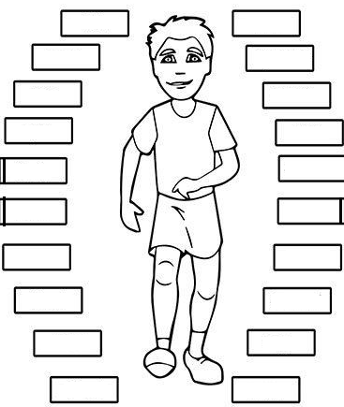**

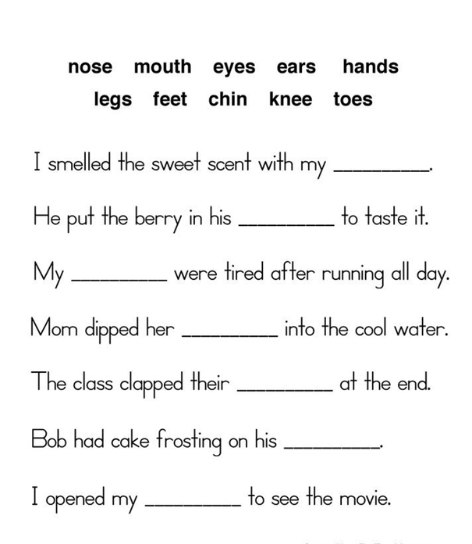 b**) Directions:** Read the sentences below. Fill in the blanks with body words. Some words may be used in more than one sentence. Some words will not be used.

|  |  |  |  |  |
| --- | --- | --- | --- | --- |
| **WEEK** | **VALUE PROMISE** | **MEMORY VERSE** | **CHARACTER TRAITS** | **WORK HABIT** |
| **NINE** | “I believe God will always help me to be devoted”. | John 3 : 16 | 1. Be so loving  2. Be prayerful and alert  3. Fear God as your teacher  4. Honor one another  5. Be faithful. | Excellence is not a skill. It’s an attitude |

John 3:16 “For God so loved the world that he gave his only begotten son, that whoever believers in him shall not perish but have eternal life”.

Work habit

Name: \_\_\_\_\_\_\_\_\_\_\_\_\_\_\_\_\_\_\_\_\_\_\_\_\_\_\_\_\_\_\_\_\_\_\_\_\_\_\_\_\_

Date: \_\_\_\_\_\_\_\_\_\_\_\_\_\_\_\_\_\_\_\_\_\_\_\_\_\_\_\_\_\_\_\_\_\_\_\_\_\_\_\_\_\_

School: \_\_\_\_\_\_\_\_\_\_\_\_\_\_\_\_\_\_\_\_\_\_\_\_\_\_\_\_\_\_\_\_\_\_\_\_\_\_\_\_\_

Spellings Corrections

1. 1.

2. 2.

3. 3.

4. 4.

5. 5.

**Past simple tense**

Verbs which change to past tense by adding “ed”

Examples

|  |  |
| --- | --- |
| brush | brushed |
| clean | cleaned |
| cook | cooked |
| help | helped |
| cover | covered |
| collect | collected |

Exercise

play push

add clean

plant work

collect cover

**Complete the sentences using the correct form of the word in the bracket.**

1. Pam her uniform yesterday. (wash)

2. Father for us at the park. (wait)

3. We many games last evening.(play)

4. It heavily last week. (rain)

5. Deborah the window last evening. (open)

6. The cat the tree yesterday. (climb)

7. The teacher Joan to bring her bag yesterday. (ask)

**Activity**

**Fill in the gaps using the past tense of the words in brackets.**

1. Mary her fingernails yesterday. (cut)

2. She the house yesterday. (mop)

3. Jackie the food at night. (cover)

4. They the compound last week. (slash)

5. Peter and Barbara the rubbish yesterday. (collect)

6. We the toilet yesterday. (scrub)

7. My mother food yesterday. (cook)

8. My father in the garden yesterday. (dig)

9. Namujju her clothes yesterday. (wash)

10. The rubbish yesterday. (collect)

**Write in yesterday (past) tense.**

|  |  |
| --- | --- |
| 1. cover covered | 7. burn |
| 2. scrub | 8. dig |
| 3. wash | 9. collect |
| 4. cut | 10. slash |
| 5. brush | 11. mop |
| 6. cook | 12. smoke |

Corrections

***Score strip***

Name: \_\_\_\_\_\_\_\_\_\_\_\_\_\_\_\_\_\_\_\_\_\_\_\_\_\_\_\_\_\_\_\_\_\_\_\_\_\_\_\_\_

Date: \_\_\_\_\_\_\_\_\_\_\_\_\_\_\_\_\_\_\_\_\_\_\_\_\_\_\_\_\_\_\_\_\_\_\_\_\_\_\_\_\_\_

School: \_\_\_\_\_\_\_\_\_\_\_\_\_\_\_\_\_\_\_\_\_\_\_\_\_\_\_\_\_\_\_\_\_\_\_\_\_\_\_\_\_

Spellings Corrections

1. 1.

2. 2.

3. 3.

4. 4.

5. 5.

**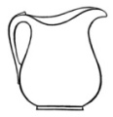Conjunction “and”**

 A cup is on the table

A jug is on the table

**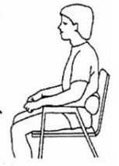**

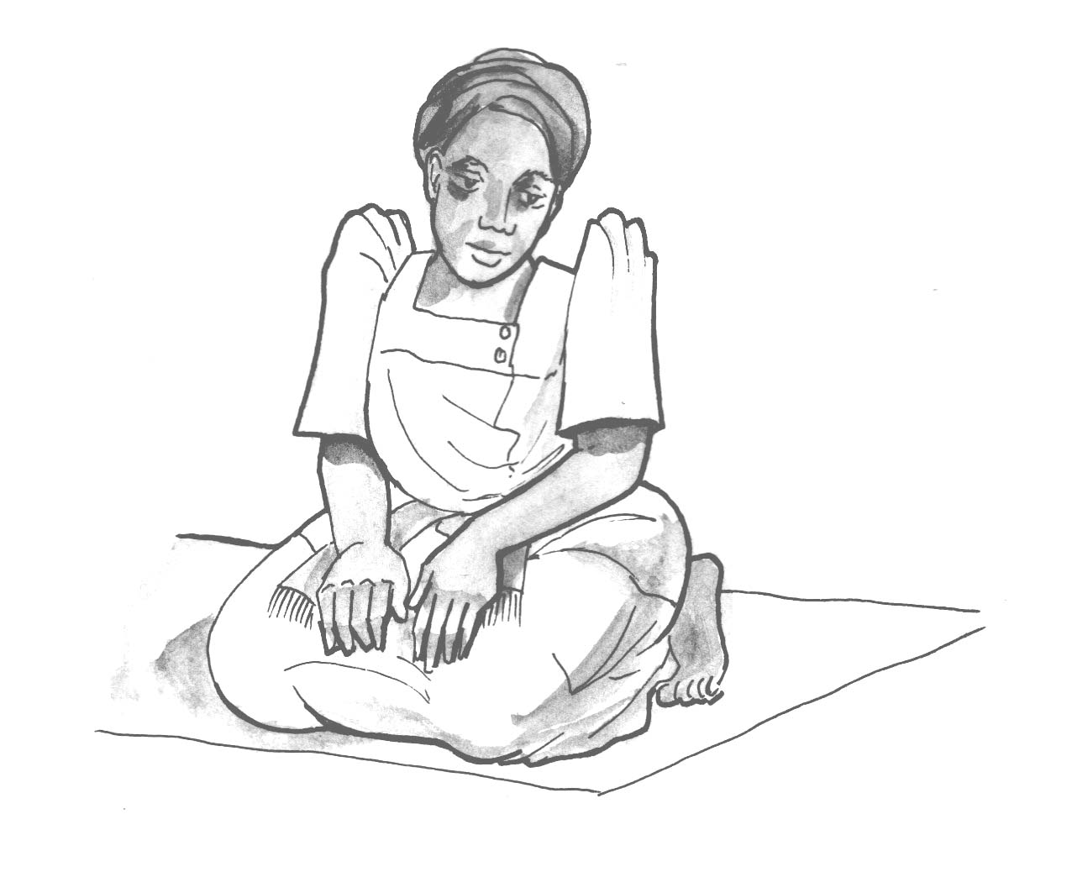B

Rhoda Peter

Rhoda is sitting Peter is sitting

**The above sentences can be written as one sentence by using and. as follows.**

**a. A cup** and a jug are on the table.

**b. Rhoda** and Peter are sitting.

**Write these pair of sentences as one sentence by using and.**

1a. I bought a book.

b. I bought a pencil.

2a. The door is open.

b. The window is open.

3a. The pencil is missing.

b. The rubber is missing.

4a. Peter is out.

b. David is out.

5a. My shirt is small.

b. My cap is small.

6a. Take money.

b. Take the basket.

7a. He is going out.

b. She is going out.

8a. Father is there.

b. Mother is there.

9a. Bring milk.

b. Bring sugar.

10a. Clean the blackboard.

b. Clean the table.

Corrections

***Score strip***

Name: \_\_\_\_\_\_\_\_\_\_\_\_\_\_\_\_\_\_\_\_\_\_\_\_\_\_\_\_\_\_\_\_\_\_\_\_\_\_\_\_\_

Date: \_\_\_\_\_\_\_\_\_\_\_\_\_\_\_\_\_\_\_\_\_\_\_\_\_\_\_\_\_\_\_\_\_\_\_\_\_\_\_\_\_\_

Spellings Corrections

1. 1.

2. 2.

3. 3.

4. 4.

5. 5.

**Jumbled story**

Re write the sentences to make a good story

1. I did not like it at first

2. He wore a green shirt

3. When I entered the market

4. Later on, I came to like it very much

5. I saw a fat man

1.

2.

3.

4.

5.

1. He looked around for help but there was none

2. As he walked along the village path

3. Musa was very frightened

4. One day last week, Musa was on his way to school

5. A small dog appeared in front of him.

1.

2.

3.

4.

5.

Corrections

***Score strip***

 Checkup 7

Supervisor’s initial \_\_\_\_\_\_\_\_\_\_\_\_\_\_\_\_

Score \_\_\_\_\_\_\_\_\_\_\_\_\_\_\_\_\_\_\_

Supervisor’s comment \_\_\_\_\_\_\_\_\_\_\_\_\_\_\_\_\_\_\_\_\_\_\_\_\_\_\_\_\_

**PROJECT WORK**

Word search

**Search for the following words in the puzzle below.**

washed, converted , waited, crossed, collected,

opened, cared , slashed, ruined, subtracted

|  |  |  |  |  |  |  |  |  |  |  |  |  |  |  |  |  |  |
| --- | --- | --- | --- | --- | --- | --- | --- | --- | --- | --- | --- | --- | --- | --- | --- | --- | --- |
| w | c | t | a | c | o | n | v | e | r | t | e | d | e | i | s | s | o |
| u | a | c | w | c | r | n | a | d | u | a | z | a | k | t | h | u | p |
| s | r | s | v | r | a | h | q | n | i | m | f | v | j | r | e | b | e |
| p | e | a | h | p | o | s | d | u | n | s | e | o | n | i | d | t | n |
| b | d | w | b | e | a | a | r | g | e | f | c | y | m | l | r | r | e |
| c | y | o | p | e | d | m |  | j | d | g | i | m | q | i | y | a | d |
| o | d | a | i | n | s | p | o | p | a | k | e | l | x | f | g | c | l |
| l | d | c | a | k | m | i | l | r | f | o | t | h | i | s | h | t | e |
| l | e | e | a | q | a | n | w | a | g | w | c | w | h | h | g | e | s |
| e | z | n | q | f | w | a | c | c | m | z | h | r | w | w | s | d | d |
| c | x | b | s | l | a | s | h | e | d | m | e | q | o | q | c | w | r |
| t | a | g | l | a | n | h | z | g | o | q | d | x | w | s | u | x | r |
| e | w | a | m | o | m | g | a | q | j | n | g | l | c | e | s | s | j |
| d | v | j | b | n | k | s | w | h | v | m | h | h | v | x | s | e | k |
| f | m | i | g | m | l | v | q | w | g | r | l | u | i | c | s | n | d |
| w | a | i | t | e | d | a | t | d | h | t | v | i | t | z | i | l | f |

|  |  |  |  |  |
| --- | --- | --- | --- | --- |
| **WEEK** | **VALUE PROMISE** | **MEMORY VERSE** | **CHARACTER TRAITS** | **WORK HABIT** |
| **TEN** | “I choose to always do the right”. | Mathew 19:14 | 1. Be appreciative  2. Be patient  3. Be self-controlled  4. Be peaceful  5. Listen to others | Never, Never, Never give up |

Mathew 19:14 “Let the little children come to me, and do not stop them: for it is to such as these that the kingdom of heaven belongs”.

Work habit

Name: \_\_\_\_\_\_\_\_\_\_\_\_\_\_\_\_\_\_\_\_\_\_\_\_\_\_\_\_\_\_\_\_\_\_\_\_\_\_\_\_\_

Date: \_\_\_\_\_\_\_\_\_\_\_\_\_\_\_\_\_\_\_\_\_\_\_\_\_\_\_\_\_\_\_\_\_\_\_\_\_\_\_\_\_\_

School: \_\_\_\_\_\_\_\_\_\_\_\_\_\_\_\_\_\_\_\_\_\_\_\_\_\_\_\_\_\_\_\_\_\_\_\_\_\_\_\_\_

Spellings Corrections

1. 1.

2. 2.

3. 3.

4. 4.

5. 5.

**Vocabulary**

|  |  |  |  |
| --- | --- | --- | --- |
| Food | cabbage | groundnut | Yam |
| Cassava | meat | bean | Potato |
| Rice | orange | pawpaw | fish |

**Activity**

**Write the words correctly.**

|  |  |
| --- | --- |
| dofo | bnea |
| mogan | wapwap |
| mlik | cagebba |
| maet | roagen |
| yma |

**Arrange the words in A, B, C order.**

1. Yam, orange, brown

2. Potato, milk, rice.

3. Mango, pawpaw, colour

4. Orange, cassava, ground nut

5. rice, cassava, groundnut

6. meat, bean, egg

Read the poem below and answer the questions.

FOOD

Cassava, cassava

When I eat cassava

I get energy

Eggs, eggs

When I eat eggs

I get proteins

Oranges, Oranges

When I eat oranges

I get vitamin C

Questions

1. What is the poem about?

2. What do we get when we eat cassava?

3. Write the food in the poem.

4. Who wrote the poem?

5. Draw the food in the poem.

**Read the passage and answer the questions in full sentences.**

Maitha has washed his plate and spoon.

He has neatly put them on a tray to dry.

Mother is still taking her supper.

Maitha will wash his mother’s plate.

Mother does not use a spoon.

She likes to use her hands when eating.

**Questions.**

1. What has Maitha washed?

2. Where is the spoon?

3. What is mother doing?

4. Why doesn’t Mother use a spoon?

**Fill in the blanks with any suitable word.**

a) Let’s go for a .

b) Can you run like a ?

c) I would like to have a .

d) It will rain in the month of .

Corrections

***Score strip***

Describing words tell us something more about nouns.

Describing words are called adjectives

I am wearing a new shirt (what kind of shirt)

We sit for meals at a round table (what kind of table)

The words new and round are adjectives. Here are some more adjectives.

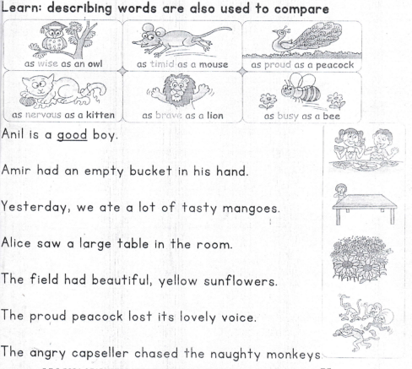

**Fill in the blanks with the correct adjectives from the list.**

cunning, heavy, square, poor, red, rich, sharp, strong

1. The cunning fox cheated the poor rabbit.

2. A knife hurt my hand.

3. The porter lifted the

bags.

4. The boy wore a cap on his head.

5. The picture was put in a frame.

6. The king gave some gold to the beggar.

Corrections

***Score strip***

 Checkup 8

Supervisor’s initial \_\_\_\_\_\_\_\_\_\_\_\_\_­­

Score \_\_\_\_\_\_\_\_\_\_\_\_\_\_\_\_\_\_\_\_\_

Supervisor’s comment \_\_\_\_\_\_\_\_\_\_\_\_\_\_\_\_\_\_\_\_\_\_\_\_

**PROJECT WORK**

Different types of food lie under different classes. Use colours to identify the given types of food to their classes.

**carbohydrates - red**

**fats-yellow**

**proteins- green**

**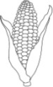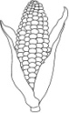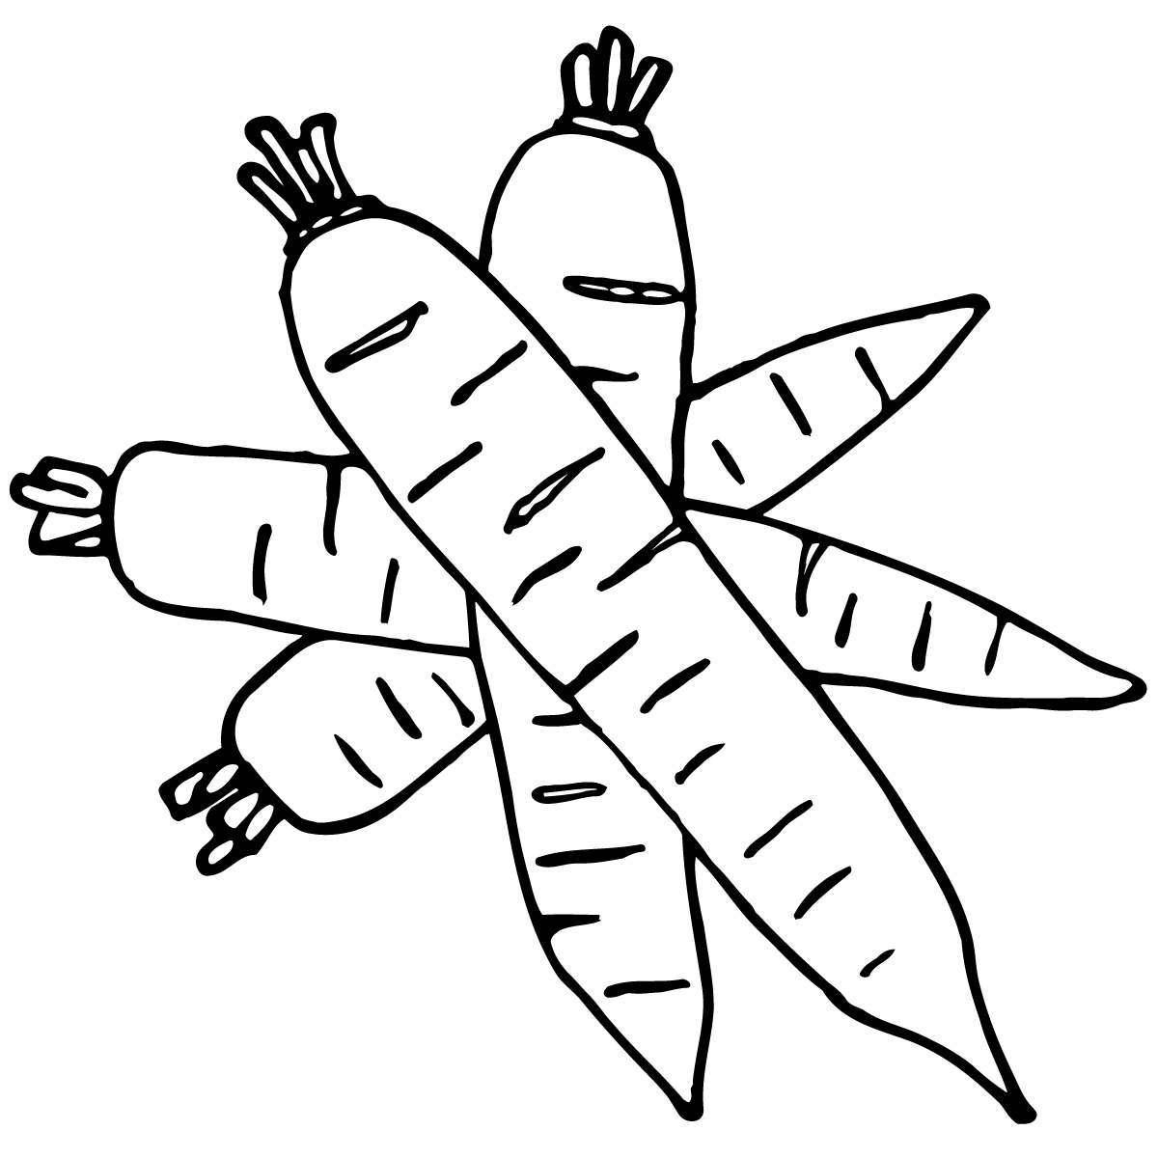vitamins- blue**